

**Surface App**

**Functional Specifications Document V1.0**

|  |  |  |  |  |
| --- | --- | --- | --- | --- |
| Version | Date | Summary of Changes | Author | Approved by |
| 1.0 | 27/02/2018 | Draft | Harshit Kaushal |  |

Contents

1. Objective 2
2. System Specification 2
3. Project Overview 2
4. Modules 2
   1. User 2
      1. Splash Screen 2
      2. Login 3
      3. Sign Up 4
      4. Forgot Username 5
      5. Forgot Password 6
      6. Reset Password 7
      7. Feeds/Home 8
      8. Search Screen 13
      9. Add Post 14
      10. Notifications 19
      11. Message 21
      12. Other User Profile 24
      13. User Profile 26
      14. Settings 29
5. Parameter Fields 32

# Objective

This FSD captures the complete software requirements for the development of Surface app. It is intended for project managers and developers. This shall be a living document and may be revised during the project lifecycle.

# System Specification

This document includes complete explanation, inclusive of: Flow of App, representing flow of all the modules. This is intended to represent full flow of project describing all the kind of user associated with this project.

# Project Overview

There will be two kinds of users who all can access the platform. Users who can view posts , search for other users and can add a post. Admin who can manage the whole system.

# Modules

# User

# Splash Screen

* User will be able to view a splash screen whenever they open the app. This splash screen will last for 3-5 seconds and following it user will be redirected to the welcome screen.
* Whenever user taps on app icon on their devices, the app will get open up. Now if the app is running in the background then app will get open to the screen where they left else every time this splash screen will appear.



# Login

* User will be able to login by entering their email address/ username/ phone number and password.
* User will be able to login through social media like facebook & google.
* User will be able to receive an error if their entered email address or password is incorrect.
* User will be able to tap on sign up which will redirect them to the sign up screen.
* User will be able to tap on forgot password which will redirect them to the forgot password screen.
* User will be able to tap on forgot username which will redirect them to the forgot username screen.

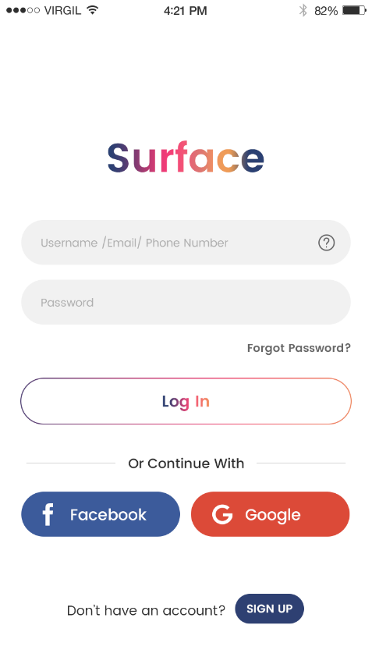 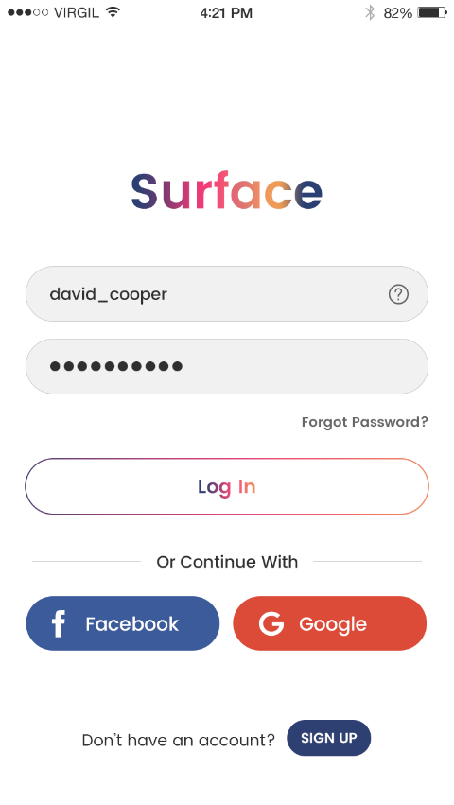

# Sign Up

* User will be able to sign up by providing their username, email address/phone number, password.
* User will be able to tap on login which will redirect them to the login screen.
* Once entering all the details user will be able to tap on sign up to proceed further to home screen. User will be able to receive an error if any of their entered detail is incorrect.

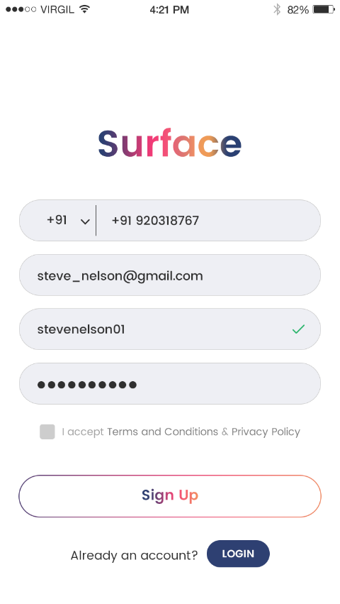 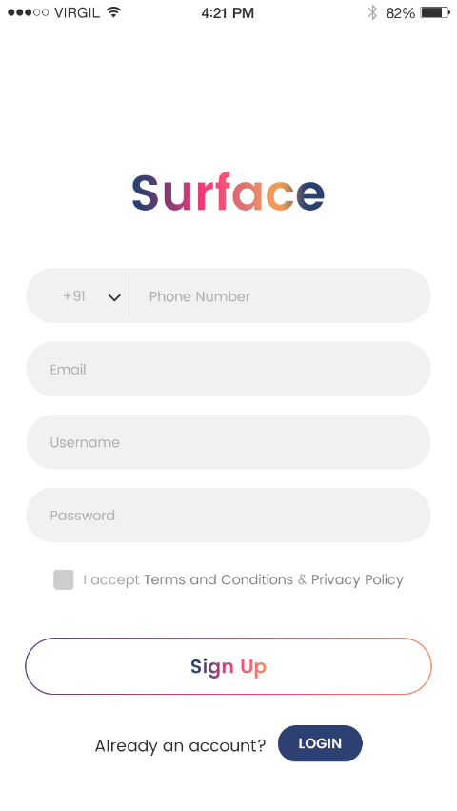

# Forgot Username

* User will be able to tap on forgot username in case they forgot their username.
* User will be able to enter their email address to receive their username.
* User will be able to receive an error message if the email address is incorrect.

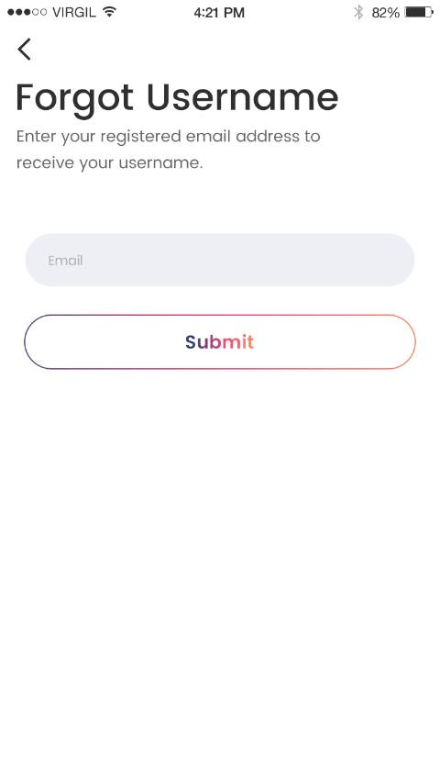

# Forgot Password

* User will be able to tap on forgot password in case they forgot their password.
* User will be able to enter their email address to reset their password.
* User will receive a link on their email address to reset their password.
* User will be able to receive an error message if the email address is incorrect.
* Once entering email address, user will be redirected to the reset screen.

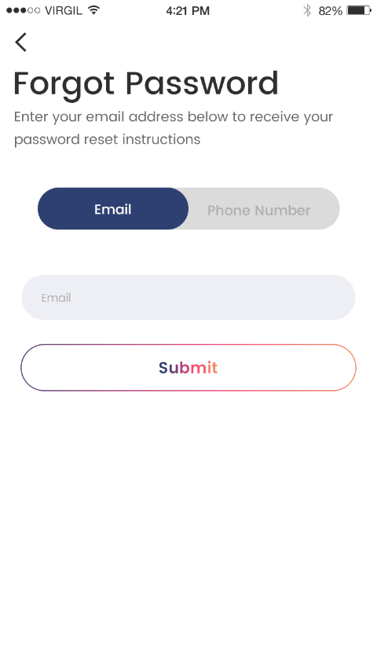 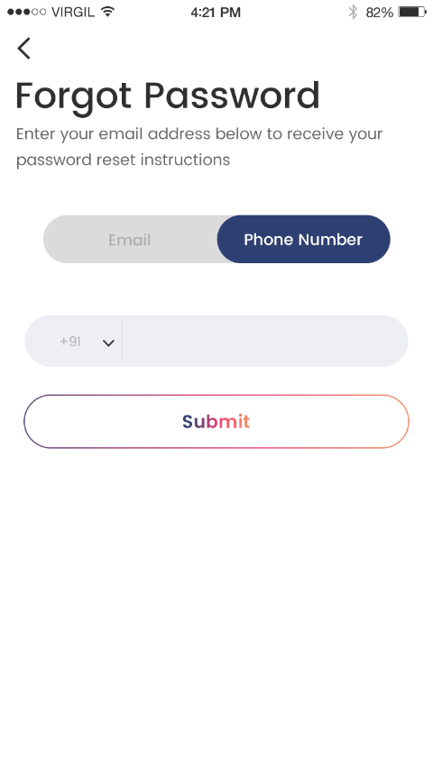

# Reset Password

* User will be able to reset their password in case they forgot their password.
* User will be able to enter a new password followed by a confirmation.
* Once resetting their password User will be redirected to the login screen.

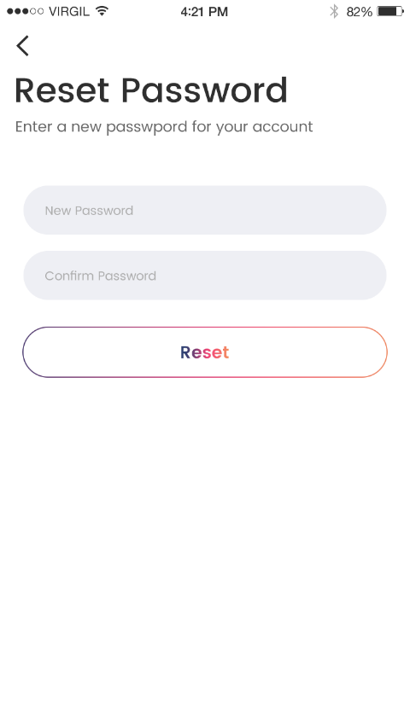

# Feeds/Home

* User will be able to view posts feed screen in the app.
* User will be able to search for any user by tapping on search icon on the top right of the screen, next to which there will be a message icon tapping on which will navigate user to messages screen.
* User will be able to view the featured posts on the top of the screen.
* User will be able to tap on any on the featured post to view the complete view of that post on a new screen. There user will see the total views, comments and tags on that post.
* User will be able to view the views, comments, posted time, posted by, and location of the posts shared.
* User will be able to perform actions like share to facebook/twitter , copy link, turn on post notifications, report any post if they want. A pop-up will be shown if user reports any post, which will have options like spam, inappropriate or other. User can also mention some other reason for reporting the post.
* User will be able to perform actions like share to facebook/twitter , copy link, edit and delete any post which they have posted. A confirmation pop-up will be shown to the user before deleting the post.
* User will be able to tap on count of views, tags and comments to see the list of views, tags and comments accordingly.
* User will be able to tap on comments icon to view all the comments on that post. User can reply to any of the comments on the post.
* User will be able to tap on any of the profile picture or name to navigate to that user’s profile.
* User will be able to edit/delete his/her own comment on the post.

# D:\Lakshay\2018\Inhouse\Surface_screens_and_logo_27_feb\Screens\2.Home\5.1_home_screen.png D:\Lakshay\2018\Inhouse\Surface_screens_and_logo_27_feb\Screens\2.Home\5.4_home_featured_viewers.pngD:\Lakshay\2018\Inhouse\Surface_screens_and_logo_27_feb\Screens\2.Home\5.10_home_screen_share_post_within_app_send_active.png D:\Lakshay\2018\Inhouse\Surface_screens_and_logo_27_feb\Screens\2.Home\5.5_home_featured_comments.pngD:\Lakshay\2018\Inhouse\Surface_screens_and_logo_27_feb\Screens\2.Home\5.6_home_other_user_post_options.png D:\Lakshay\2018\Inhouse\Surface_screens_and_logo_27_feb\Screens\2.Home\5.7_home_other_user_own_post_options.png

# D:\Lakshay\2018\Inhouse\Surface_screens_and_logo_27_feb\Screens\2.Home\5.8_home_screen_share_post_send_inactive.png D:\Lakshay\2018\Inhouse\Surface_screens_and_logo_27_feb\Screens\2.Home\5.9_home_screen_share_post_searching_friend.pngD:\Lakshay\2018\Inhouse\Surface_screens_and_logo_27_feb\Screens\2.Home\5.3_home_featured_tagged_users.png D:\Lakshay\2018\Inhouse\Surface_screens_and_logo_27_feb\Screens\2.Home\5.2_home_featured_post.png

# Search Screen

* User will be able to search for any user within the app by tapping on search icon on the home screen.
* User will be able to search for any nearby user by tapping on a nearby icon which will be there on the search screen. If the nearby user’s location is on, then the list of those users will be shown to the user through which the user can view their profile and add them as a friend.

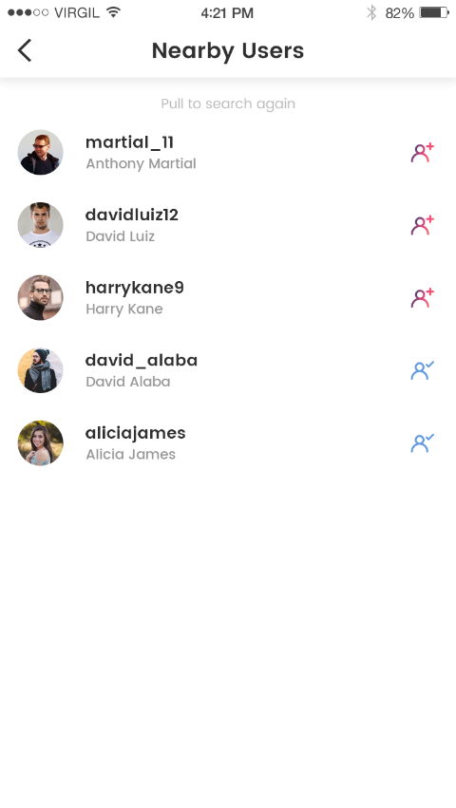 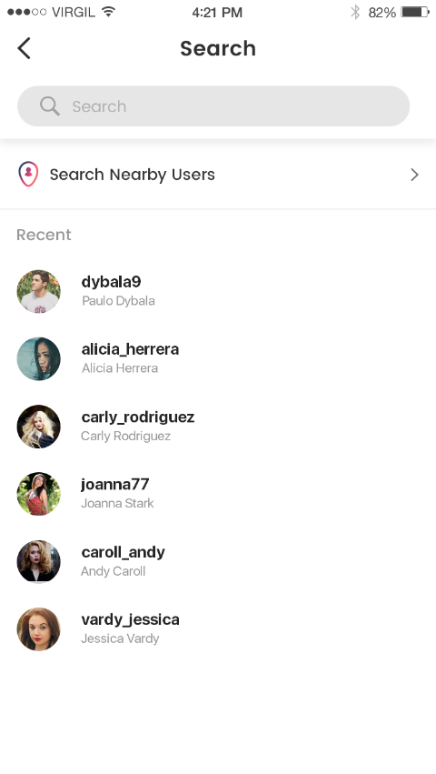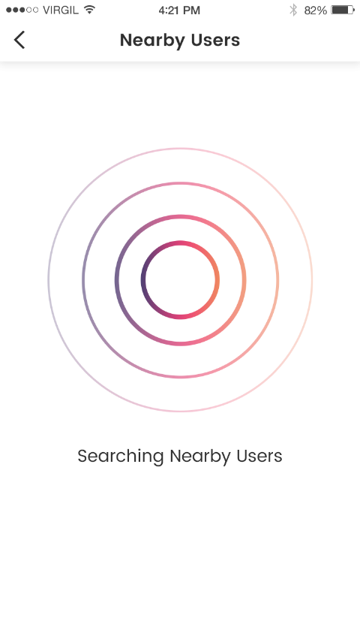 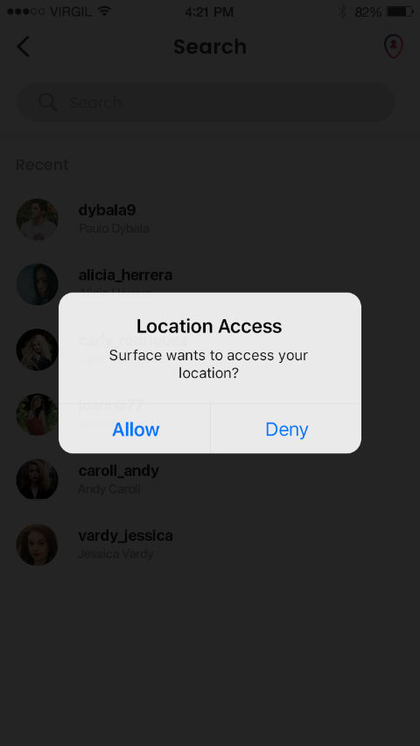

# Add Post

* User will be able to add a new post by tapping on add icon in the center of the bottom bar.
* User will be able to access the gallery or camera to post an image/video once the user allows the access to his/her gallery and camera, which will be shown to the user as a pop-up once he/she clicks on the add icon.
* User will be able to upload image of any size and also there won’t be any time limit for the video if it is being uploaded from gallery. If recording from phone, time limit will be of one minute.
* User will be able to add location for the image which he/she is uploading.
* User will be able to tag his/her app friends in the image which user wants to upload. User will tap on the image and then list of the app friends will be shown, user can select from the list or search for any other friend whom user wants to tag in that image.
* User will be able to apply filters on the image from the given options of filters in the app.

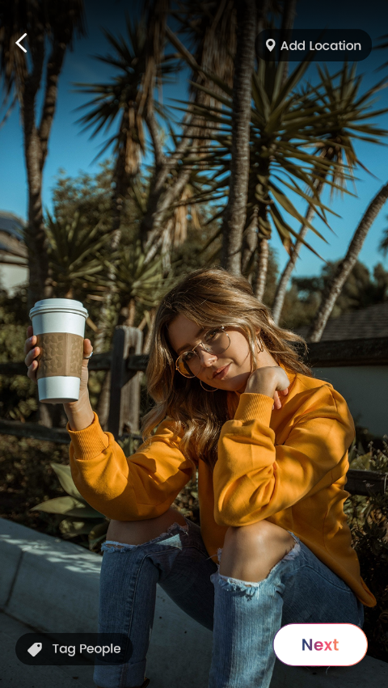 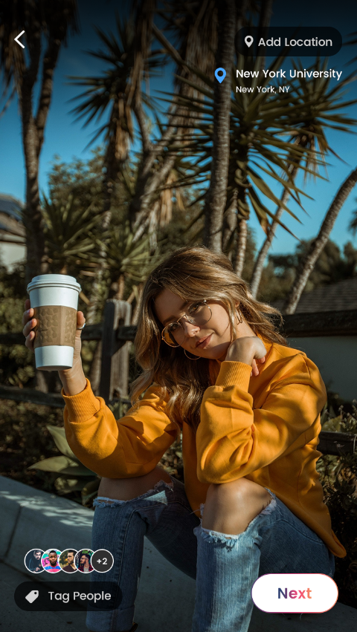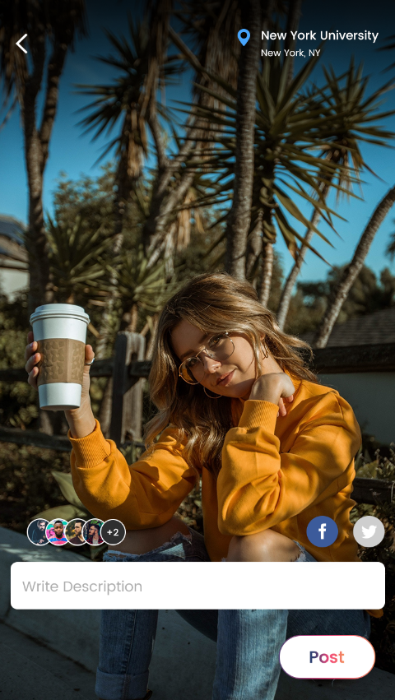 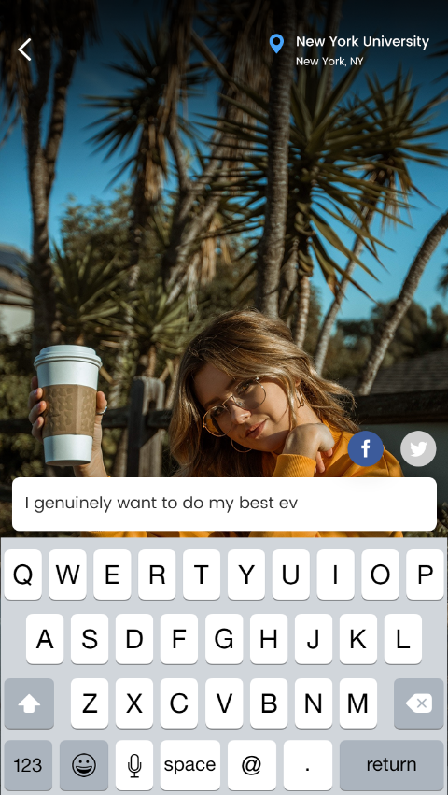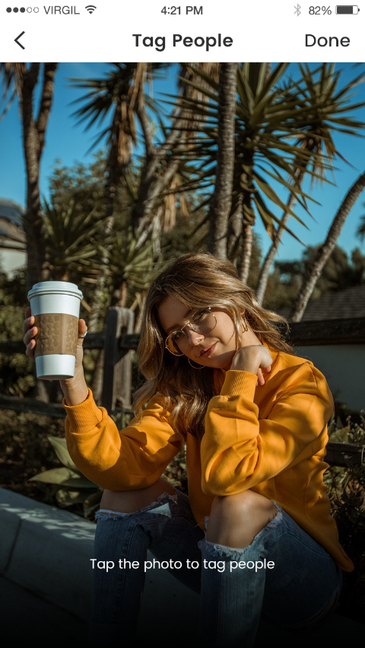 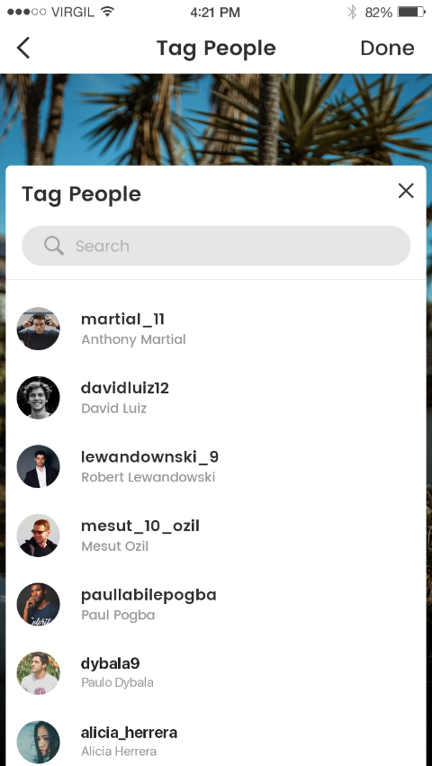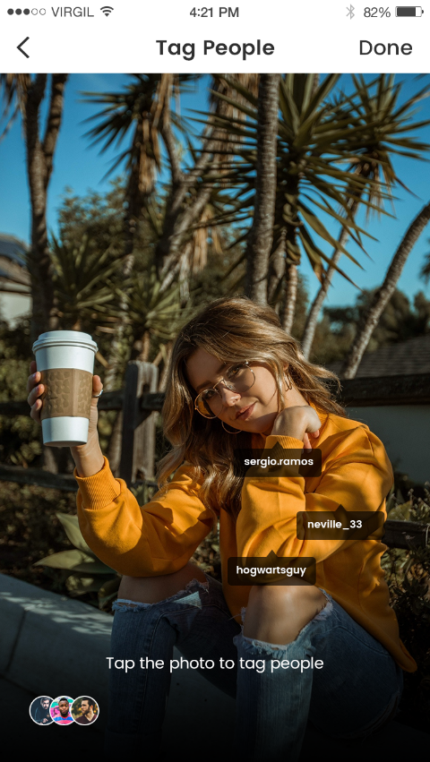 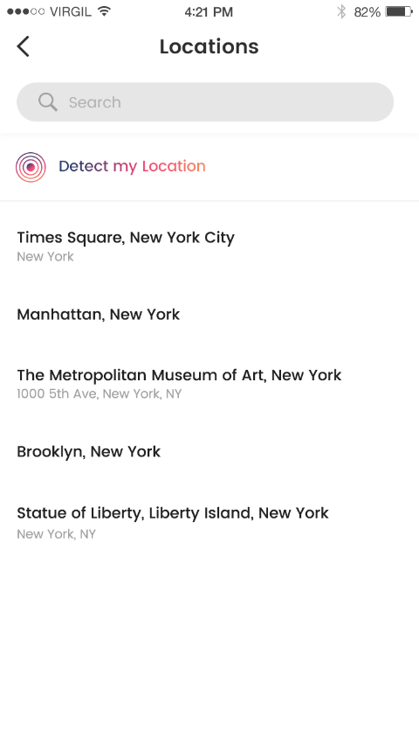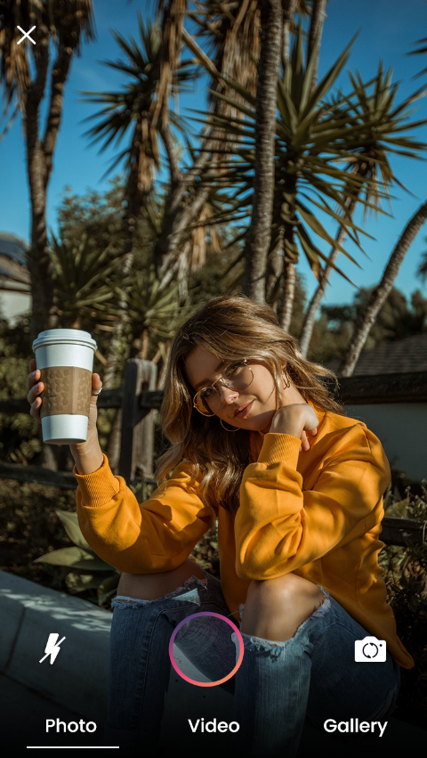 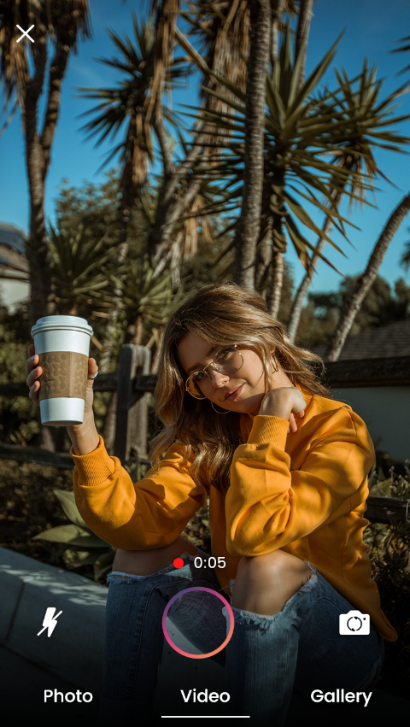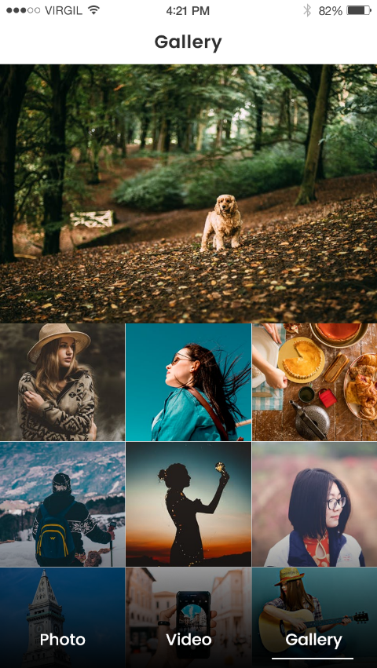 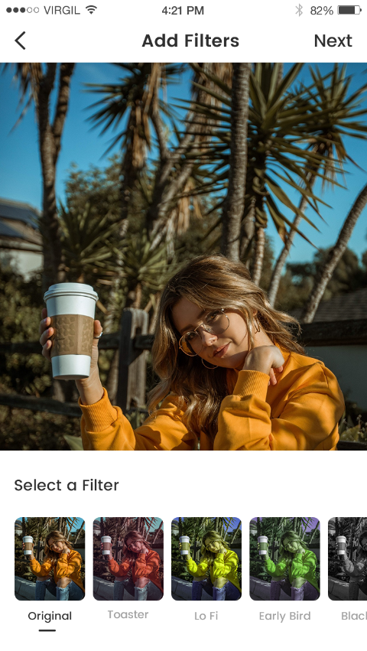

# Notifications

* User will be able to view notifications related to like and comments on user’s post.
* User will be able to view notifications if any other user has send the friend request , or if user’s request has been accepted by other user.
* User will be able to view notifications if any other user tags the user on any of the post.
* User will be able to view any notification from admin side.

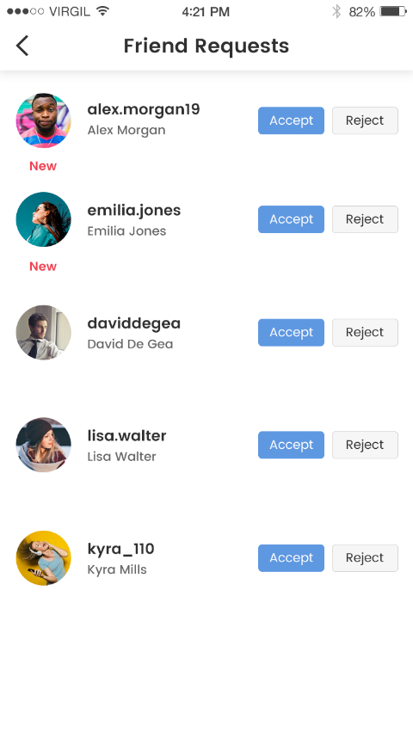 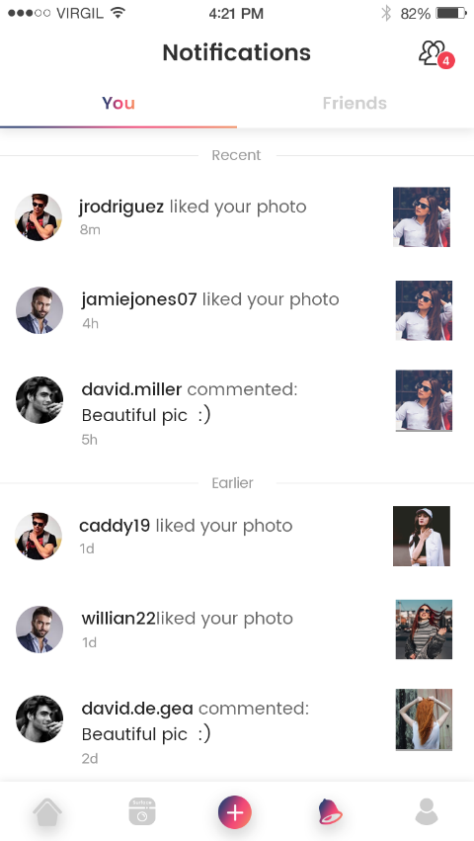

# Message

* User will be able to tap on message icon on the home screen to navigate to the messages list screen.
* User will be able to tap on ‘+’ icon if user wants to initiate a conversation, after which user will be able to view list of his/her app friends and then user can search for his/her friend and send the message.
* User will be able to send text messages and emoticons in the chat module.
* User will be able to mute any conversation from any particular user, clear chat , report and block that user. A confirmation pop-up will be shown to user in case he/she wants to block any user.
* User will be able to see unread messages count on top of the messages list with the name of the user who have send the message.

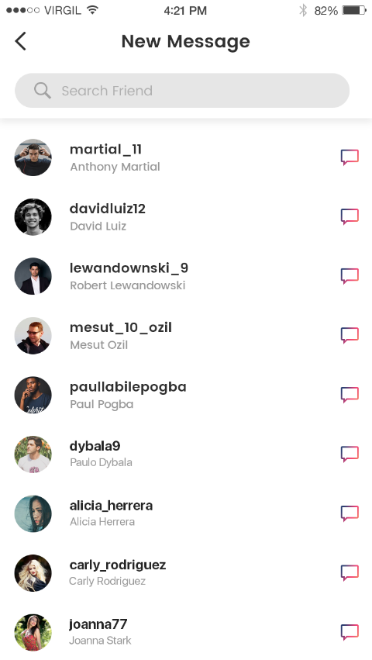 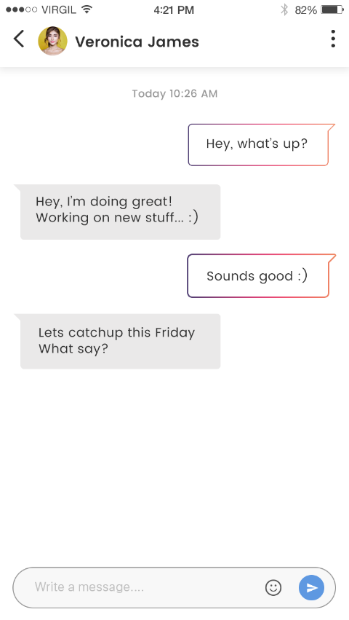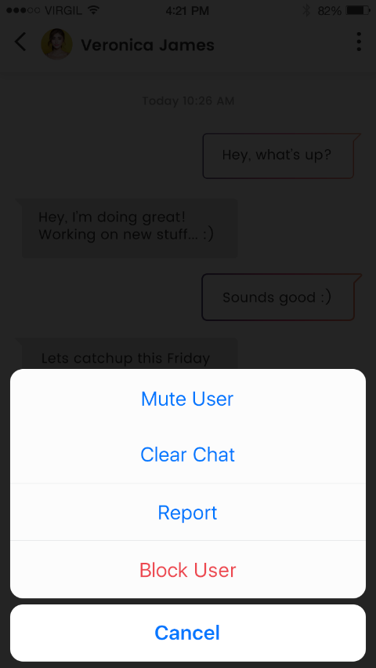 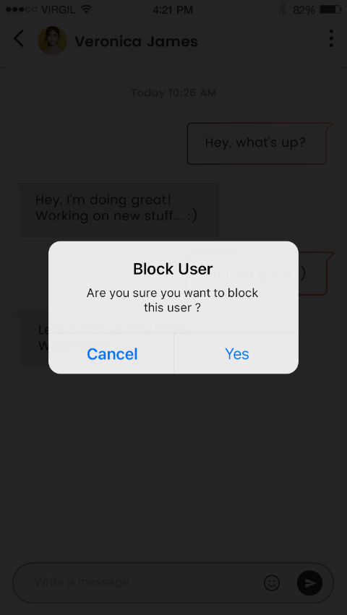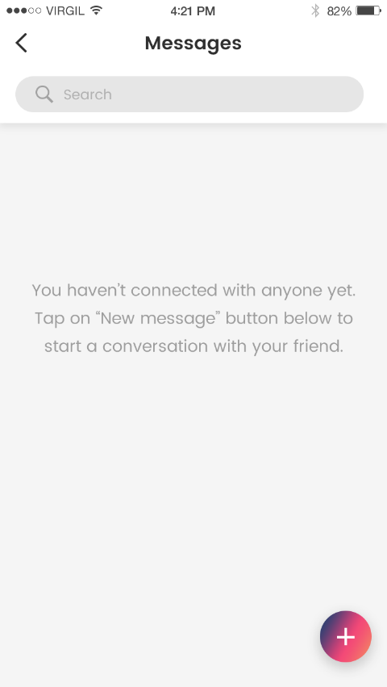 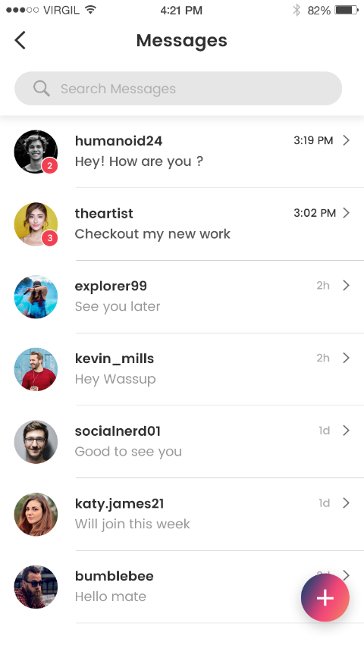

# Other User Profile

* User will be able to tap on any other user’s name or profile image to navigate to their profile.
* User will be able to view other user’s basic details like their name, username , age, location, DOB, about, website link, total number of posts and friends .
* User will be able to send them friend request and message by tapping on ‘add friend’ and ‘message’ respectively. User will be able to unfriend any user if they are already friends with each other.
* User will be able to tap on number of posts to view all the posts made by that user, and also can tap on number of friends to view the list of that user’s friends.
* User will be able to share other user’s profile , turn on post notification for that user, report and block that user.

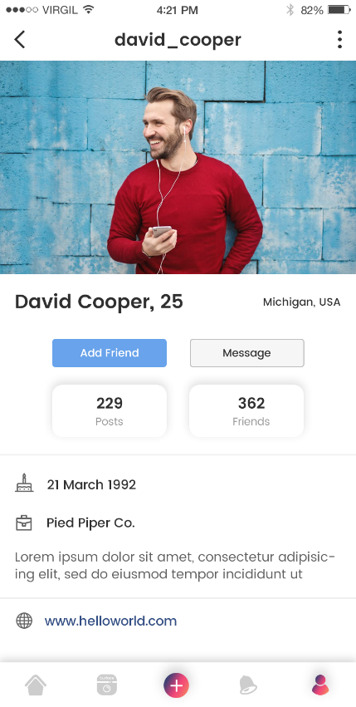 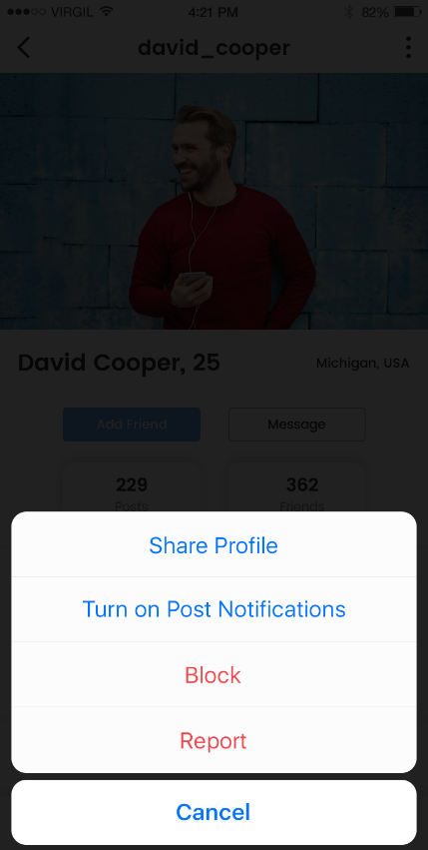

# User Profile

* User will be able to view their profile in the app.
* User will be able to view their name, username , age, location, DOB, about, website link, total number of posts and friends in their profile.
* User will be able to edit their profile by tapping on ‘edit profile’ on the screen where they will be able to edit their details.
* User will be able to tap on setting icon which will navigate them to the settings screen.

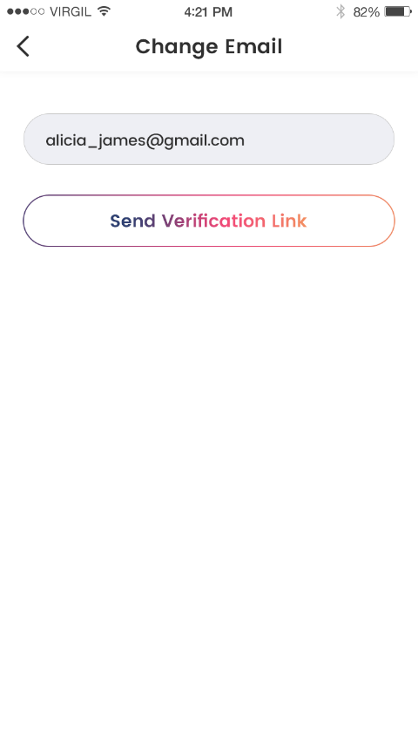 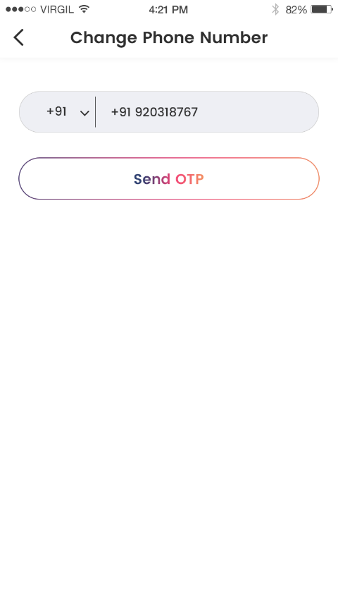 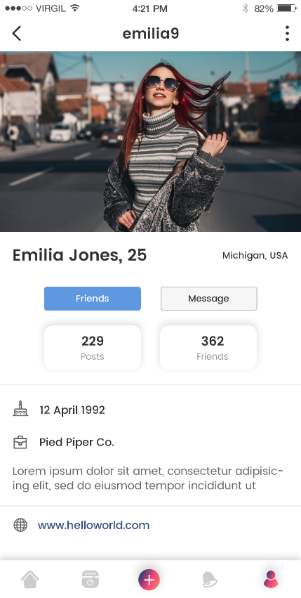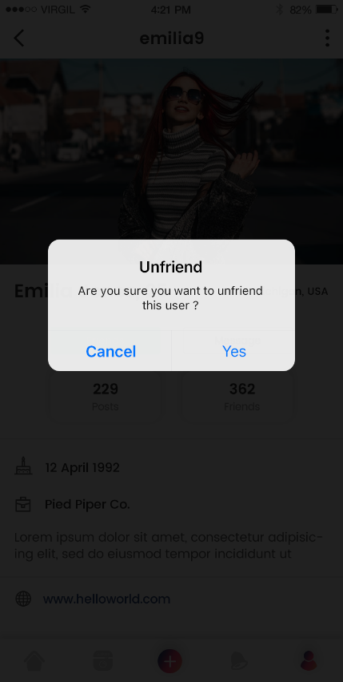 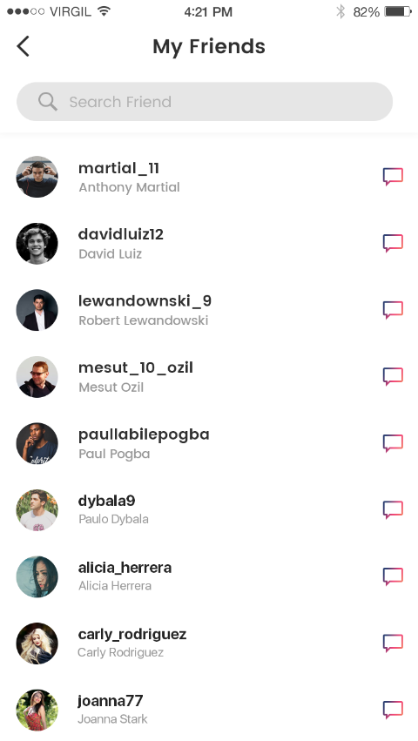 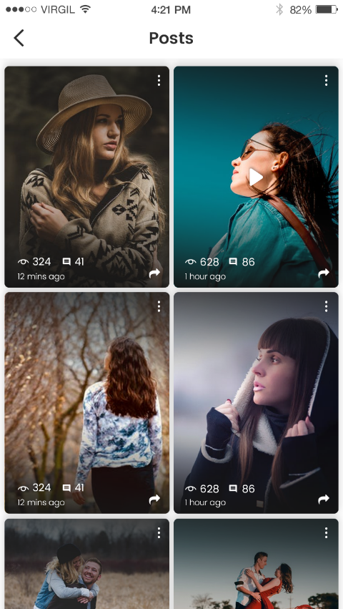 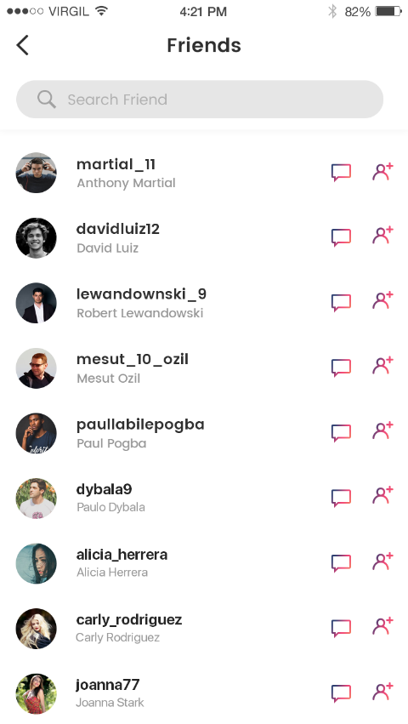 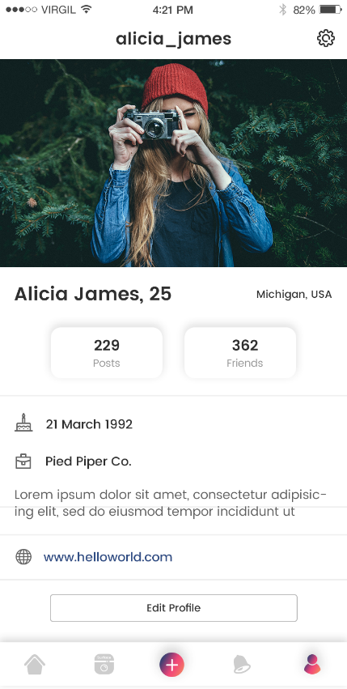  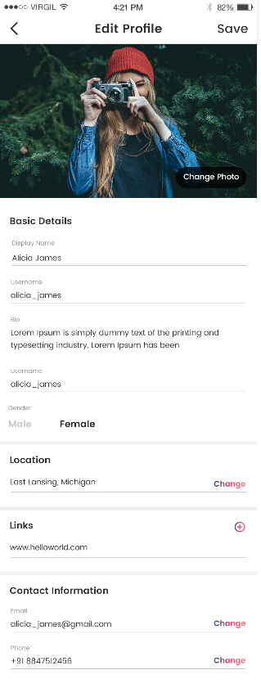

# Settings

* User will be able to tap on push notifications. User will be able to on/off push notifications by tapping on toggle button.
* User will be able to change their password by tapping on this option. They will be able to enter an old password, new password followed by a confirm password to change their password.
* User will be able to view about us section in settings. They will be able to tap on it to view information.
* User will be able to tap on ‘blocked users’ to see the list of users whom user have blocked. User can unblock any user from that list.
* User will be able to tap on ‘invite user’ to invite users to the app, which will open the native share kit through which user can invite the users.

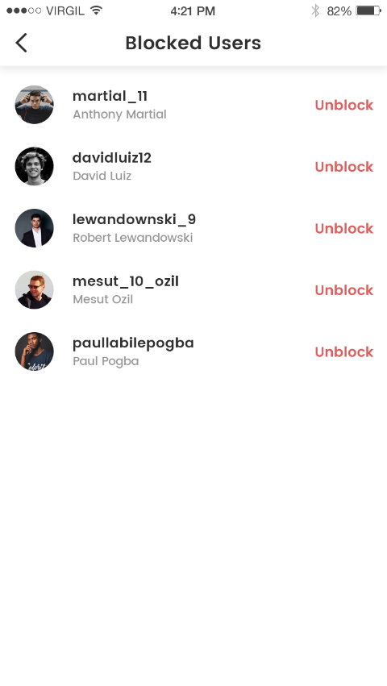 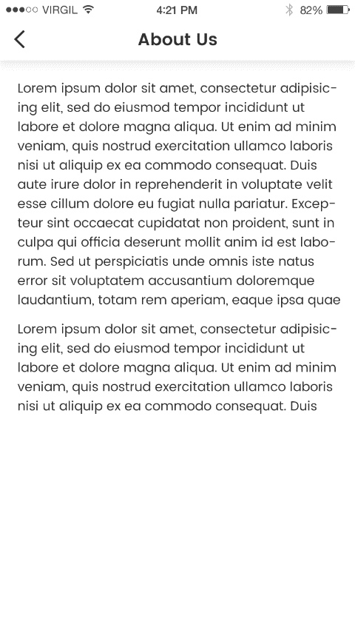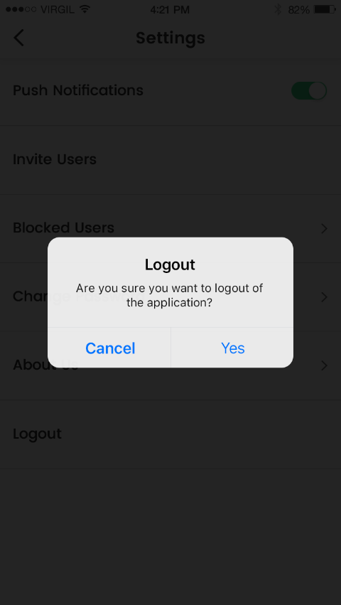 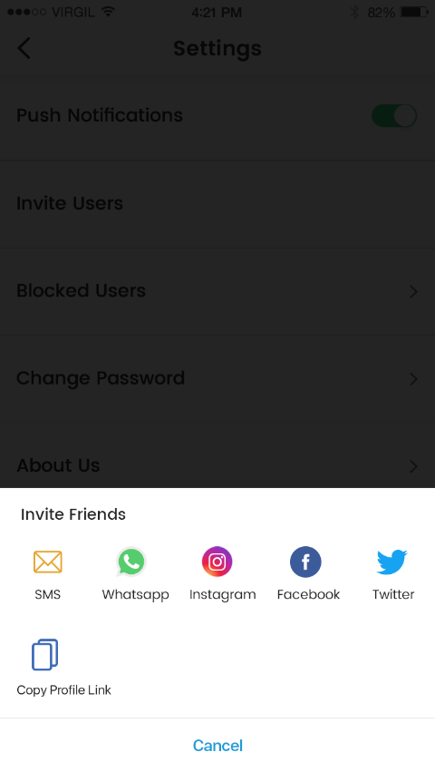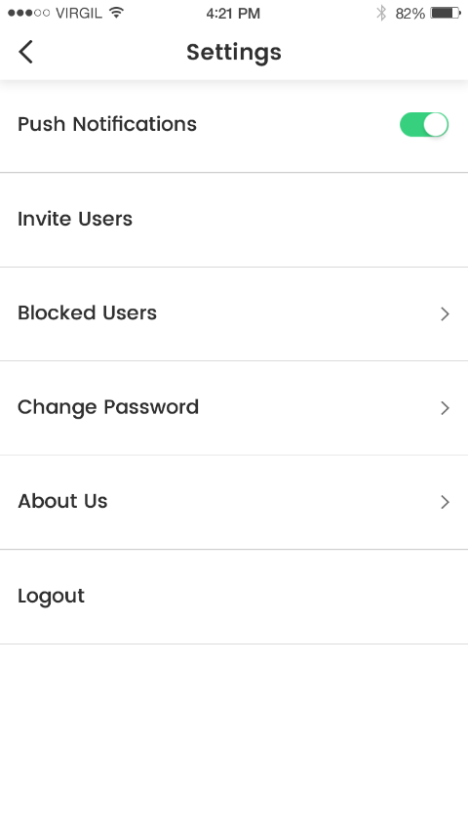 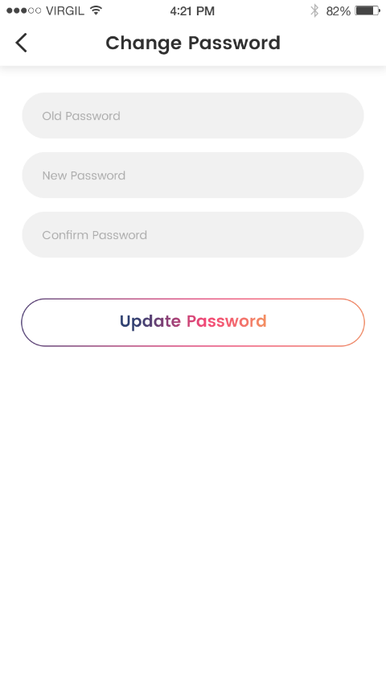

# Parameter Fields

|  |  |  |  |
| --- | --- | --- | --- |
| **Name** | **Type** | **Description** | **Restrictions** |
| Email address | Alphanumeric and special characters | As per email format | 10-30 character |
| Password | Alphanumeric and special characters | As per password format | 10-30 character |
| Name | Text Field | Only alphabets are allowed | 2-20 character |
| Username | Alphanumeric | Only Alphanumeric | 10-15 character |